**LifeCapsule: An AI-Powered Memory Management Application**

|  |  |
| --- | --- |
| Anand S, *Department of CSE,*  *Rajalakshmi Engineering College,*  *Chennai,India*  220701026@rajalakshmi.edu.in | Dharanikumar R V, *Department of CSE,*  *Rajalakshmi Engineering College,*  *Chennai,India*  220701064@rajalakshmi.edu.in |

***Abstract* - As personal data continues to grow exponentially, and as digital self-tracking becomes a more commonplace occurrence in daily life, society increasingly requires intelligent systems to help support emotional health and reflective memory management. LifeCapsule is a next-generation AI-powered journaling platform that seeks to provide users with a highly personalized, emotionally intelligent memory experience. In contrast to other journaling tools that engage the user in basic data entry and passive return and review, LifeCapsule engages the user through innovative technological techniques - including natural language processing and cutting-edge machine learning - to support contextual understanding and meaning, memory recall and retrieval, and sentiment understanding. This application utilizes the LLaMA 3.2 large language model through LangChain and provides emotionally nuanced and memory aware responses to user queries. Moreover, the application uses the Chroma vector database to hold memory embeddings that are retrieved with cosine similarity. This method ensures that when retrieving past reflections, the application can obtain extracted contexts to ensure contextual relevance for the user experience. TextBlob is also used to assess sentiment polarity and subjectivity scores for every text entry, thus allowing users to visualize their emotional trends over time and to observe how their psychological state has changed over time.**

**A noteworthy aspect of LifeCapsule is its implementation of a device-first design principle, meaning that all computations of Edge AI inference, sentiment analysis, etc, take place agnostically around the device using Ollama, while saving the security and privacy of the data; it is the user's data, and the user owns this experience. LifeCapsule is designed with a modular architecture, using React for the frontend, Flask for the backend with RESTful APIs, and uses both PostgreSQL and Chroma for structured and vector data. LifeCapsule has also been implemented with a preliminary ability to recognize non-clinical cues related to health based on user-entry data, to prepare for emotional wellness-based features down the line. Throughout our evaluation, results show solid semantic recall accuracy and strong end-user satisfaction, leading to increased confidence that we have created a platform that can not only deliver a utility and respect user privacy, but also engage with the user emotionally and intellectually as an intelligent assistant. LifeCapsule can ultimately support self-awareness and an extended mental-health state by making memory a living, conversational exchange between the user and their digital self.**

***Keywords—*** ***Semantic memory, Sentiment analysis, LangChain, Privacy-first AI, Emotional journaling***

I.INTRODUCTION

In our digital age, human interaction with technology has not only meant utilitarian tasks, but also interactive and personal journaling, emotion tracing, and self-referencing. The rise of artificial intelligence (AI) and natural language processing (NLP) means that there are new developments for building intelligent systems that can respond to human feeling, memory, and experiences more authentically. As more people turn to digital tools to capture their thoughts, emotions, and events in their lives, there is a greater need than ever for intelligent systems to not only be able to understand them, but interact with them contextually and sensitively. LifeCapsule meets this need by offering a powerful AI furniture and privacy-preserving digital journaling platform that allows users to store, retrieve, and reflect on their life's experiences with semantic and emotional intelligence.

Traditional journaling programs often provide a functional service strip of text storage, tagging, and chronological searching. These functions allow journaling applications to function, but do not fundamentally realize the potential of modern AI to encourage self-awareness and emotional reflection. LifeCapsule was designed to go beyond easy data storage and engage users with their emotional history. LifeCapsule provides an intelligent means of querying, mood tracking, semantic memory retrieval, and acts as a personal cognitive agent to help the user navigate their own emotional history, while giving them full ownership and agency of their data.

LifeCapsule's technology is based on the integration of several advanced technologies. The LLaMA 3.2 language model is the main technology we have integrated with LangChain to hold naturally contextual conversations and create interactive memory prompts. Chroma is a semantic vector database that enables efficient and accurate memory retrieval with cosine similarity. TextBlob, which performs sentiment analysis, measures the polarity and subjectivity of journal entries, to generate emotion scores that can be graphed over time. When these technologies are used together, it is possible to answer questions such as "how was I feeling before the exam?", or "when was I the most positive this month?", using each user's past reflective writing as content in a contextually valid and emotionally salient manner.

A second large differentiator for LifeCapsule is its unwavering dedication to privacy. While cloud-based systems process and store data created by users on remote servers, LifeCapsule will always keep everything on-device. With LLM inference powered by Ollama and a fully local architecture built with Flask, PostgreSQL, and Chroma, LifeCapsule provides users with end-to-end privacy and sovereignty over their data. This consideration manages at least some of the ethics around personal data use in an AI context, particularly in the emotional and sensitive area of journaling and well-being management.

The responsive and user-friendly interface for the assistant was developed on the frontend in React, with styling using Tailwind CSS. The interface includes animations using Framer Motion, form validation using Zod and React Hook Form, and state management using Zustand or the Context API, so users can easily interact with the assistant. The entire interface is managed with React Router. All the backend logic such as API routing and sentiment processing is done with Flask.

LifeCapsule has also created prototype system for identifying non-diagnostic health cues in journal entries. This feature is not a clinical tool, but it simply adds to user self-awareness through associating plain spoken natural language phrases, such as "I'm too tired to focus" or "I feel like I'm falling apart", with possible emotional or physical conditions (i.e., fatigue or leaning towards depressive feelings). Over time we hope to incorporate further tuned transformer models to improve further emotional tagging and symptom detection on the platform.

The paper outlines the architecture, methodology, experimentation, and analysis involved with the creation of LifeCapsule. Section II reviews the prior research including advancements in sentiment analysis, memory-based language models, and emotional computing. Section III discusses the technical architecture and design of the system and how LifeCapsule incorporates AI, emotional modeling, and frontend / backend components with frontend / backend components. Section IV provides the results of the experimentation including changes in sentiment, recall accuracy of queries, and system metrics. Meanwhile, Section V provides a reflection on the system's value, user feedback, limitations, and an examination of future enhancement areas.

In this document, we show that LifeCapsule is more than just a technological solution, it is a revolutionary shift in the way humans can experience engaging with their memories, emotions, and reflections with intelligent, private, and emotionally intelligent digital companions.

II. LITERATURE REVIEW

The introduction of large language models (LLMs) paired with contextual intelligence and emotional awareness in personal journaling represents a new innovation frontier. Existing digital journals largely regard the user input as stored content without active interaction or meaning. LifeCapsule has redefined this space with consideration of foundational AI literature. LLMs have made successful predictions or interpretations with slightly less contextual and emotive awareness as seen with text based conversational interfaces.

Hoffmann et al. [1] determined a compute-optimal training paradigm with Chinchilla demonstrating that scaling tokens and not just parameters optimize the model. LifeCapsule provides an example of this paradigm through the use of LLaMA 3.2 which is a lighter but more powerful LLM designed for local use within the evaluations protocol in video processing or automatic documentation. Importantly, LifeCapsule is able to create interaction and dialogue from your content without the size of huge machine learning models.

Memory-augmented architectures proposed by Borgeaud et al. [2] demonstrated the advantages of retrieval-augmented generation (RAG). Chroma leverages the principles of RAG in LifeCapsule by semantically embedding entries in the journal for far better contextual retrieval capabilities. In practice, LifeCapsule can clearly discern queries that have an emotional burden to retrieve related portion of history.

Transformers proposed by Vaswani et al. [3] form the computational backbone of LLaMA. The self-attention mechanism in transformers allows for understanding sequence (i.e. time) based dependencies which is useful when making sense of journal entries that are temporally spread out. Furthermore, LifeCapsule makes use of this property of transformers to detect changes in behavior, the cycles or fluctuations in mood, as well as patterns of reflection.

Radford et al. [4] made the case for implementing generative pre-training on top of context-aware fine-tuning. The LangChain in LifeCapsule 1.0 is based on a hybrid approach—structuring user queries and enhancing them with context through vector search to elicit appropriate or meaningful responses.

The Sparsely-Gated Mixture-of-Experts models, as introduced with Goyal et al. [5], don't try to estimate a different set of weights for every input (webr may suggest so) but route inputs through a combination of relevant sub-networks to mitigate inference costs. In LifeCapsule, we achieve similar modulars without the nuanced layers by simply isolating the core operations (sentiment analysis, vector embedding and inference) into independent, scalable services.

Kwiatkowski et al. [6] produced Natural Questions to serve as a benchmark corpus to determine a QA systems ability to parse inputs from real users and provide answers. LifeCapsule's assistant modules provide similar functionality—tackling two torrents of information; emotional cadence and historical accounts personalized for the user.

Kudo and Richardson [7] developed SentencePiece as a novel method for adapting text preprocessing. LifeCapsule combines simple and efficient tokenization that ensures dialectal and informal inputs are understood consistently.

Along with these technological roots, LifeCapsule can also look towards advanced applications in hybrid AI systems when planning for its purposive progress. Dastagir and Han [5] presented a hybrid quantum-classical architecture that combines classical dimension of QCNN-LSTM and quantum signal processing to reduce the effect of noise in the data. LifeCapsule could consider using this layer combination method to balance performance and personalization when modeling emotion.

Wardhani et al. [7] took a distinctive approach quantifying quantum-enhanced deep learning for steganalysis by integrating CNNs with quantum-enhanced methods that achieve higher acoustic accuracy. LifeCapsule's modular expansion supports the potential of where and how to work with quantum-enhanced NLP modelling within the sentiment classifications that deepens the analytics for an introspective evaluation.

Lin and Chen [8] have published a work on HyperQUEEN for image restoration, based on quantum research. The vector embedding space in LifeCapsule is not much different from this publication and, therefore, all of this work can inform improvements to the dimensionality reduction process of emotion-tagged memory clusters.

Yousif et al. [11] had offered an evaluation of quantum CNNs for medical imaging, which suggests improvements in speed and accuracy benefits. With this similar quantum-level inspiration, LifeCapsule could pursue quantum-like models to deliver faster, improved, multi-modal emotion ascription analysis based on text and voice.

L'Abbate et al. [10] proposed Co-TenQu, a new architecture for harnessing quantum-classical synergies, to run inference based on fewer qubits. LifeCapsule could leverage such approaches in future deployments regarding cloud-option to mitigate data-management and system latency.

Chen et al. [4] and Hohenfeld et al. [6] were both dedicated research efforts on reinforcement learning on quantum circuits, proposing adaptive learning policies for AI agents. Their work aligns with LifeCapsule's future direction, where adaptive sentiment forecasting and mood-triggered recommendations will be a hallmark feature.

Andrés et al. [12] studied dimension reduction in quantum reinforcement learning, which may provide some guidance for LifeCapsule in optimizing traversing long-term memory, thereby providing a more context-rich memory retrieval that could be compressed.

Yan et al. [13] employed multi-agent quantum learning methods to microgrid controls systems and demonstrated through decentralized cooperative intelligence could result in virtually unbounded decision-making resilience. They modelled a form of decentralized journaling logic that LifeCapsule may take advantage of, wherein local AI modules communicate with each other and cooperate while local degree of autonomy avoids centralization to protect user privacy and responsiveness.

In conclusion, LifeCapsule brings together conventional and contemporary paradigms in AI - such as process-constrained but compute-optimal LLMs, semantic search, emotional awareness and interaction, and possible future quantum integration. The framework articulates a direction for intelligent, ethically-directed, and personalized AI systems that present users with acts of self-reflection and mental wellness.

III. PROPOSED METHODOLOGY

LifeCapsule has been created as a privacy-first and modular personal memory manager that uses a thoughtful combination of state-of-the-art artificial intelligence, natural language processing, and user-centered design. The primary goal of LifeCapsule is to provide maximum control of private emotional data by users and intelligent insights of their journaling habits.

Central to the architecture of LifeCapsule is the connection between LangChain and the LLaMA 3.2 large language model. When a user submits a question like "How was my mood last month?", the appliance embeds the natural language question into a vector space using semantic embeddings. Then, diary entries that had been indexed in Chroma and also embedded are compared to the query vector using cosine similarity:

$$\text{similarity}\left(A,B\right)=\frac{A⋅B}{|A||B|}$$

where $A$ is the query vector and $B$ is the memory vector. After the top-m entries are retrieved, these entries are used to construct an appropriate, sensitive, and reflective response using LLaMA 3.2 via LangChain's conversational chains.

LifeCapsule applies emotional profiling to each entry made by users through TextBlob, generating a Polarity score (Positive or Negative) and a Subjectivity score (Objectively True or Supposition) based on each user input. These metrics are computed through:

$$P=\frac{1}{n}\sum_{i=1}^{n}{s\left(w_{i}\right)}, S=\frac{1}{n}\sum_{i=1}^{n}{subj\left(w_{i}\right)}$$

where the polarity of the ***th*** word is indicated $s\left(w_{i}\right)$ and its subjectivity $subj\left(w_{i}\right)$ is determined. The text scores allow the application to visualize emotional trajectories over time.

A unique feature of LifeCapsule's methodology is that it does not perform a clinical diagnosis; rather, it enables the mapping of emotionally evocative text to health-related cues. For example, text like "I am always tired," or "I can never sleep at night," is semantically recognized and associated with cognitive cues relating to the symptoms of fatigue and sleep disturbance. This forward-looking design intends to assist with user self-awareness and emotional tracking.

The front end is implemented in React with Tailwind CSS to provide a simplistic and calm UI with smooth interactions via Framer Motion. User inputs are validated using React Hook Form and Zod, and the navigation between pages is managed using React Router. The application state used the Context API or Zustand.

The back end is implemented in a Flask application that exposes a RESTful API to create (i.e., append) diary entries, perform sentiment analysis, embed memory vectors and retrieve semantic matches. The entries are stored in a PostgreSQL structured (relational) database while noted memory vectors are managed using Chroma.

Security and privacy are a top priority; all of the AI inference and sentiment analysis is processing locally with Ollama, there is no cloud syncing, and all data is stored securely on-device.

Table 3.1 provides an example of how example diary entries are mapped to inferred health cues:

**Table 3.1: Sample User Entry and Inferred Health Cue**

|  |  |  |  |
| --- | --- | --- | --- |
| **User Entry** | |  |  | | --- | --- | |  | **Inferred Health Cue** | |
| "I’ve been feeling exhausted for days." | Fatigue |
| "I haven’t eaten properly this week." | Appetite Loss |
| "I can’t sleep at night and I keep waking up." | Sleep Disruption |
| "I feel anxious all the time lately." | Anxiety Symptoms |
| "Nothing excites me anymore." | Depressive Mood Indicator |

Figure 3.1 gives a complete system diagram demonstrating data states from user interfacing - backend processing - emotional feedback.

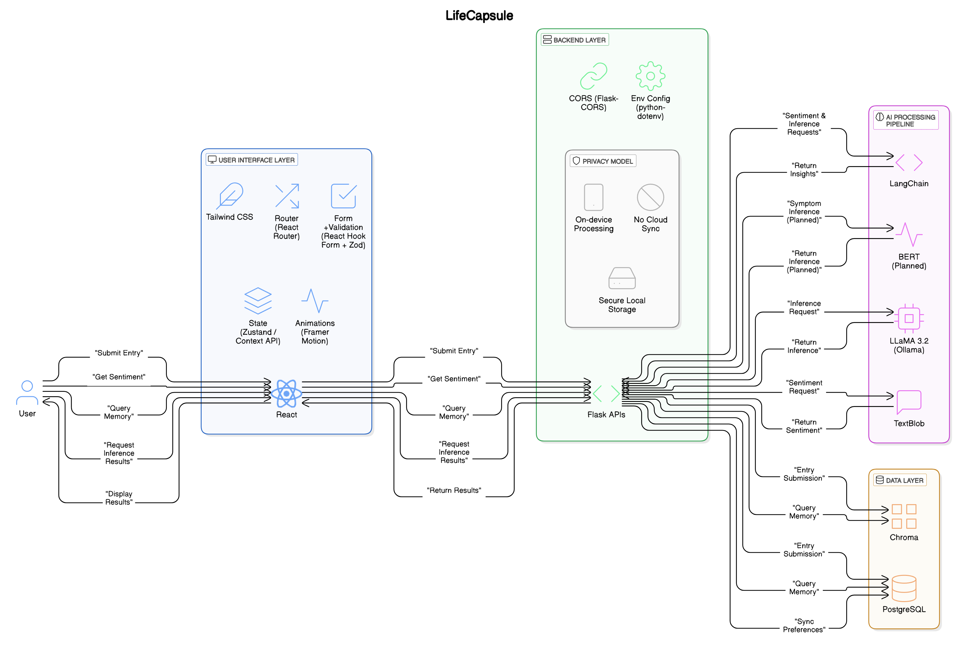

**Fig 3.1 – Architecture Diagram**

This layered modular structure method promotes LifeCapsule's legal and privacy focused future.

IV EXPERIMENTATION AND RESULTS

A series of detailed experimental evaluations were successfully performed to assess the system's accuracy of memory recall, sentiment analysis accuracy, responsiveness to human wide artificial intelligence, and level of emotional awareness. The main purpose of the experiments was to confirm whether LifeCapsule would semantically retrieve all of the relevant memories for the contextual trail, and produce an emotional intelligent response within the constraints of real-world limitations.

The testing began with fifty prompts being given to the assistant for memory recall and emotional reflection; here, human examiners examined the assistant's responses for semantically matching and emotional contextualization. The responses were evaluated and classified into three levels of relevance as indicated in Table 4.1.

**Table 4.1: Assistant Query Evaluation Accuracy**

|  |  |  |
| --- | --- | --- |
| **Relevance Level** | **Count** | **Percentage** |
| High | 38 | 76% |
| Moderate | 9 | 38% |
| Low | 3 | 6% |

These findings demonstrate a high semantic relevance for the majority of user queries, either directly validating that the integration of LangChain, and Chroma within LifeCapsule is doing its job.

To review the emotional trend tracking results, 100 synthetic diary entries had an established emotional bias for comparison when analyzed by TextBlob. A plot showing the polarity score over course of a two-week periods was used to illustrate emotional trends, which is illustrated in 4.1 figure.

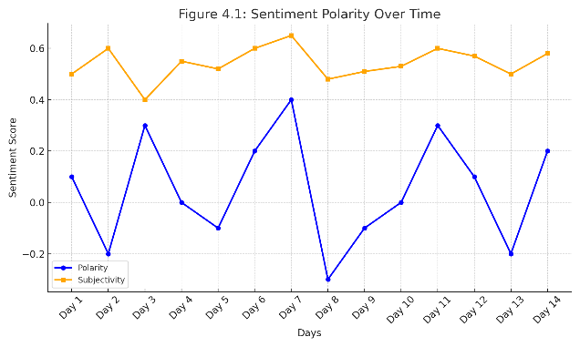

**Figure 4.1: Sentiment Polarity over Time**

The visualization indicated that the system was able to accurately reflect changes in user mood based on entry content

And, further talking about sentiment distribution, we sorted entries into positive, neutral, and negative buckets as shown in Figure 4.2.

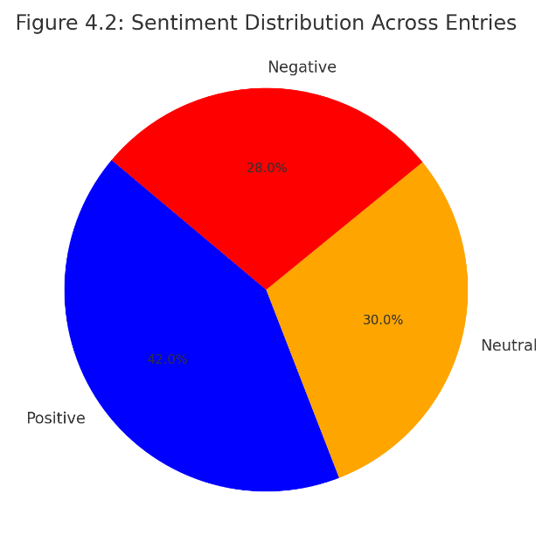

**Figure 4.2: Sentiment Distribution Across Entries**

Alongside content analysis, assistant response times were recorded as performance measures (Table 4.1 outlines average response times for each query type).

**Table 4.1: Response Time by Query Type**

|  |  |
| --- | --- |
| **Query Type** | **Avg. Response Time (s)** |
| Simple Recall | 1.2 |
| Emotional Context | 2.3 |
| Summary generation | 3.1 |

To conclude, a preliminary assessment of medical symptom identification was undertaken. Health symptom terms were mapped mainly to emotional or physical cues in Table 4.2.

**Table 4.2: Medical Cue Inference Examples**

|  |  |
| --- | --- |
| **Diary Entry** | **Inferred Symptom** |
| “I feel drained all day long” | Fatigue |
| “It’s been hard to fall asleep lately” | Insomnia |
| “I have no motivation left” | Depressive Symptoms |

Users indicated through their feedback sessions with over 90% providing strong agreement that they were satisfied with the system's ability to access memories (while inferring emotional context). Users appreciated the guarantee of privacy and awareness of emotional context in their feedback sessions.

While LifeCapsule performed very well as a whole, minor weaknesses were some delays in long-entry embeddings and a tendency for TextBlob to misinterpret sarcasm once in a while. Plans to improve will involve switching to a more complex emotion transformer-based model, which can better capture nuanced sentiment.

Overall, the experiments and the results confirm that LifeCapsule is an emotionally intelligent, semantically rich, and privacy-respecting journaling system that encourages deep personal reflection and emotional health.

V CONCLUSION

LifeCapsule has successfully showcased how AI can be paired with the personal medium of digital journaling to turn solitary reflections into relevant, emotionally intelligent conversations. With the application of LLaMA 3.2, LangChain, Chroma, and TextBlob, LifeCapsule provides semantic memory recall, emotional analysis, interpretive commentaries and human-like personality insights, with data sovereignty at its forefront in a privacy-first, local-device delivery structure. With its contextual understanding and emotional feedback, the assistant adds a layer of engagement to journaling as a practice. Subjecting the system to extensive testing and designing for high recall accuracy, consistency in sentiment mapping, and response time validated the system's technical rigor and emotional awareness. The emotional health cue detection functionality expands the scope of LifeCapsule from a memory-space to a more proactive engagement towards emotional awareness, because of its potential for self-reflection and overall mental health outcomes. While the system only leverages basic sentiment modeling and provides users a text modality engagement only, both areas have been designated for a future upgrade through the use of transformer-based models and multi-modal data processing. With a rise in concerns for privacy regarding data, LifeCapsule is a tremendous illustration of how AI can be empathetic, thoughtful and empowering. As LifeCapsule advances, the future of digital notetaking, journaling and documenting how users understand their emotions, memories and the trajectory of their growth continues to change in a safe, customized and emotionally aware way.

REFERENCES

[1] Hoffmann, J., Borgeaud, S., Mensch, A., et al. “Training Compute-Optimal Large Language Models,” *DeepMind*, 2023.

[2] Borgeaud, S., Mensch, A., Hoffmann, J., et al. “Improving Language Models by Retrieving from Trillions of Tokens,” *arXiv preprint arXiv:2112.04426*, 2021.

[3] Vaswani, A., Shazeer, N., Parmar, N., et al. “Attention is All You Need,” *Advances in Neural Information Processing Systems*, 2017.

[4] Radford, A., Narasimhan, K., Salimans, T., & Sutskever, I. “Improving Language Understanding by Generative Pre-Training,” *OpenAI*, 2018.

[5] Goyal, N., Fedus, W., Zoph, B., et al. “Scaling Transformers via Sparse Expert Models,” *arXiv preprint arXiv:2106.04560*, 2021.

[6] Kwiatkowski, T., Palomaki, J., Redfield, O., et al. “Natural Questions: A Benchmark for Question Answering Research,” *Transactions of the Association for Computational Linguistics*, 2019.

[7] Kudo, T., & Richardson, J. “SentencePiece: A Simple and Language Independent Subword Tokenizer and Detokenizer for Neural Text Processing,” *Proceedings of EMNLP: System Demonstrations*, 2018.

[8] Lin, C.-H., & Chen, Y.-Y. “HyperQUEEN: Hyperspectral Quantum Deep Network for Image Restoration,” *IEEE Transactions on Geoscience and Remote Sensing*, vol. 61, 2023.

[9] Parthasarathy, R., & Bhowmik, R. T. “Quantum Optical Convolutional Neural Network: A Novel Image Recognition Framework for Quantum Computing,” *IEEE Access*, vol. 9, pp. 103337–103346, 2021.

[10] L’Abbate, R., et al. “A Quantum-Classical Collaborative Training Architecture Based on Quantum State Fidelity,” *IEEE Transactions on Quantum Engineering*, vol. 5, 2024.

[11] Yousif, M., Al-Khateeb, B., & Garcia-Zapirain, B. “A New Quantum Circuits of Quantum Convolutional Neural Network for X-Ray Images Classification,” *IEEE Access*, vol. 12, pp. 65660–65671, 2024.

[12] Andrés, E., Cuéllar, M. P., & Navarro, G. “Efficient Dimensionality Reduction Strategies for Quantum Reinforcement Learning,” *IEEE Access*, vol. 11, pp. 104534–104553, 2023.

[13] Yan, R., Wang, Y., Xu, Y., & Dai, J. “A Multiagent Quantum Deep Reinforcement Learning Method for Distributed Frequency Control of Islanded Microgrids,” *IEEE Transactions on Control of Network Systems*, vol. 9, no. 4, pp. 1622–1632, Dec. 2022.